ЛАБОРАТОРНАЯ РАБОТА №9. Самал Бибара, ИС 25-21.
№7 Базовый. По введенному ID получить данные пользователя /users/{id}; показать имя, город и компанию.
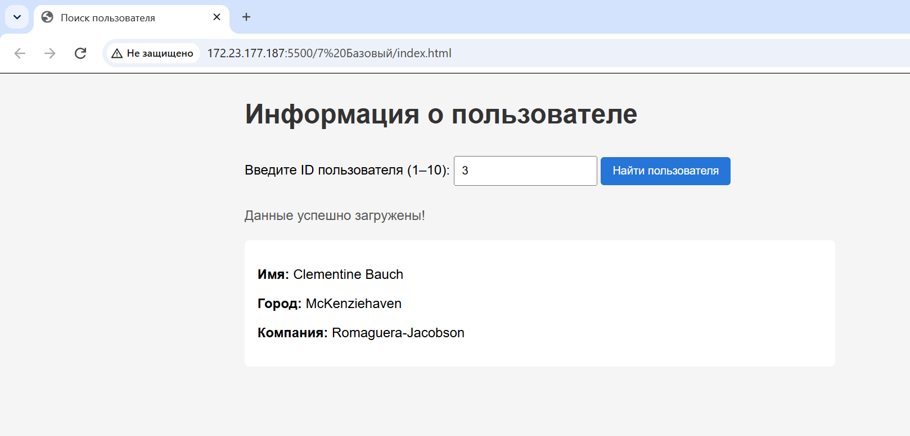
Коды:
App.js:
document.addEventListener('DOMContentLoaded', () => {
const button = document.querySelector('#load');
const userIdInput = document.querySelector('#userId');
const status = document.querySelector('#status');
const results = document.querySelector('#results');

if (!button || !userIdInput || !status || !results) {
alert('Ошибка: проверьте элементы в index.html');
return;
}

button.addEventListener('click', async () => {
status.textContent = 'Кнопка нажата! Проверяем данные...';
results.replaceChildren();

const id = userIdInput.value.trim();

if (!id || Number(id) < 1 || Number(id) > 10) {
status.textContent = 'Введите ID от 1 до 10';
return;
}

button.disabled = true;
status.textContent = 'Загрузка...';

try {
const response = await fetch(
'https://jsonplaceholder.typicode.com/users/' + id
);

if (!response.ok) {
throw new Error('Сервер ответил: ' + response.status);
}

const user = await response.json();

results.innerHTML =
'<p><b>Имя:</b> ' + user.name + '</p>' +
'<p><b>Город:</b> ' + user.address.city + '</p>' +
'<p><b>Компания:</b> ' + user.company.name + '</p>';

status.textContent = 'Данные успешно загружены!';
} catch (error) {
status.textContent =
'Ошибка: не удалось загрузить данные. Проверьте интернет.';
console.error(error);
} finally {
button.disabled = false;
}
});
});

index.html:

<!DOCTYPE html>
<html lang="ru">
<head>
<meta charset="UTF-8">
<meta name="viewport" content="width=device-width, initial-scale=1.0">
<title>Поиск пользователя</title>
<link rel="stylesheet" href="style.css">
<script src="app.js" defer></script>
</head>
<body>
<h1>Информация о пользователе</h1>

<label for="userId">Введите ID пользователя (1–10):</label>
<input type="number" id="userId" min="1" max="10" placeholder="Например, 1">

<button id="load">Найти пользователя</button>

<p id="status"></p>
<div id="results"></div>
</body>
</html>

style.css:

body {
font-family: Arial, sans-serif;
max-width: 700px;
margin: 30px auto;
padding: 0 16px;
background: #f5f5f5;
}

h1 {
color: #333;
}

input {
padding: 8px;
width: 150px;
margin: 10px 0;
}

button {
padding: 9px 14px;
cursor: pointer;
background: #2675d8;
color: white;
border: none;
border-radius: 4px;
}

button:disabled {
background: #999;
cursor: not-allowed;
}

#results {
margin-top: 20px;
padding: 15px;
background: white;
border-radius: 6px;
}

#status {
color: #555;
}

№13 Средний. Создать карточки пользователей с кнопкой «Показать публикации»; подгружать записи по клику.
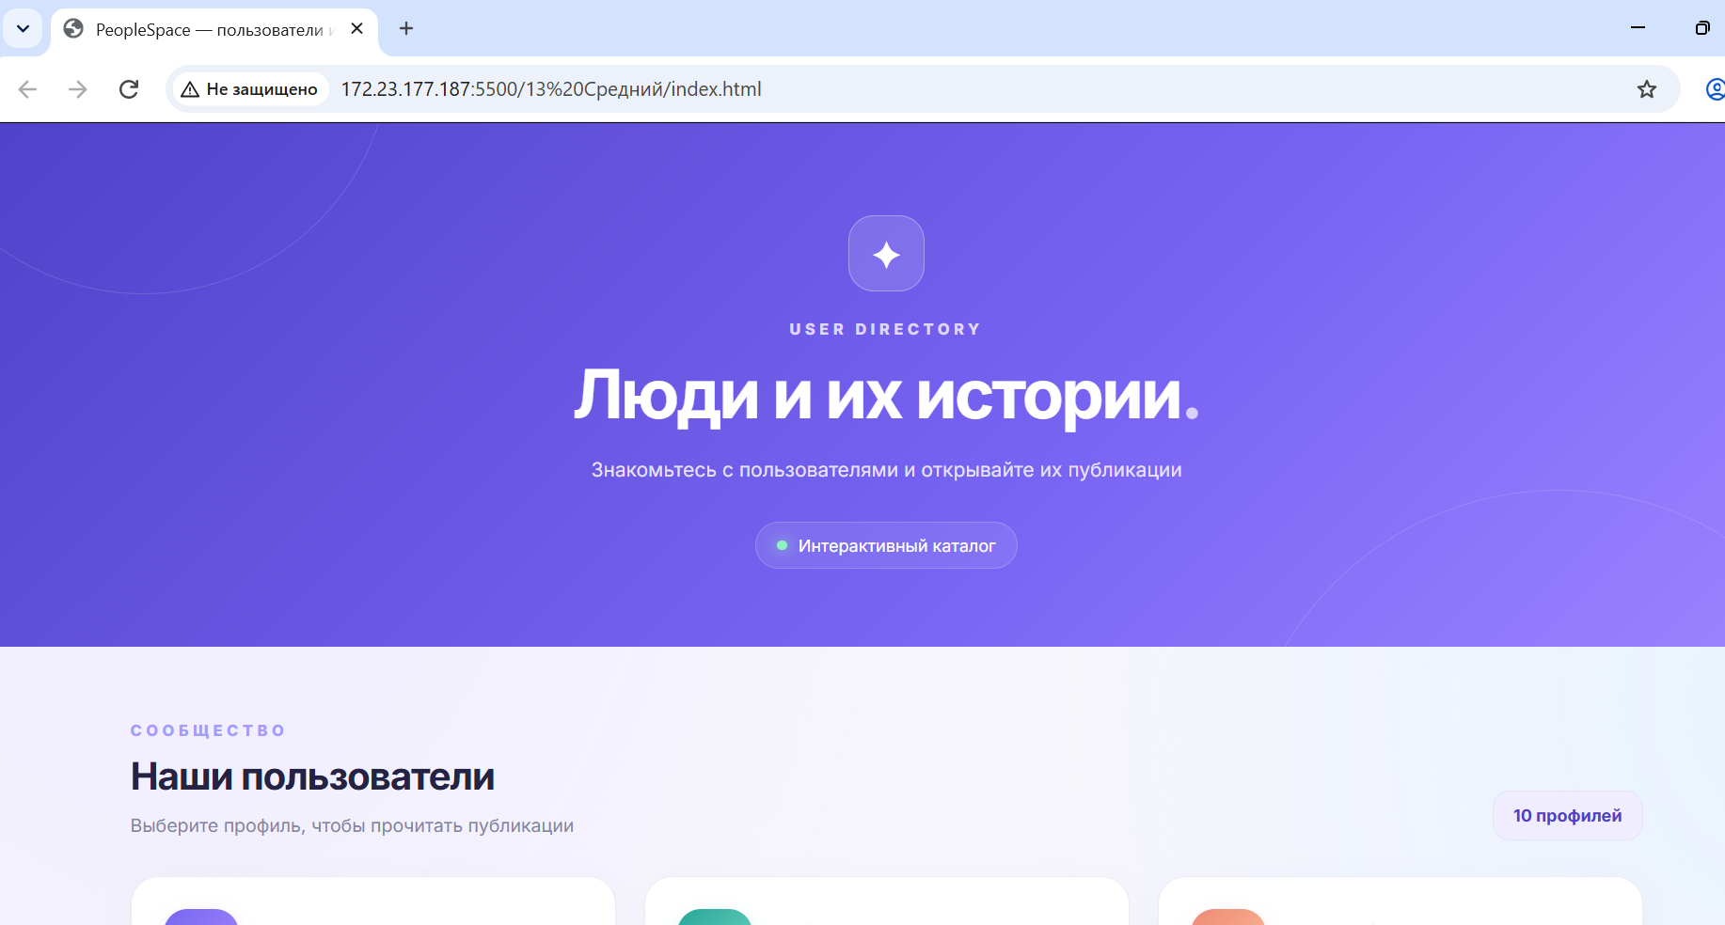

App.js:
document.addEventListener('DOMContentLoaded', () => {
const usersContainer = document.querySelector('#users');
const status = document.querySelector('#status');
const usersCount = document.querySelector('#usersCount');

async function loadUsers() {
try {
const response = await fetch(
'https://jsonplaceholder.typicode.com/users'
);

if (!response.ok) {
throw new Error('Не удалось загрузить пользователей');
}

const users = await response.json();

usersContainer.replaceChildren();
status.textContent = '';
usersCount.textContent = `${users.length} профилей`;

users.forEach((user, index) => {
const card = document.createElement('article');
card.className = 'user-card';
card.style.animationDelay = `${index * 60}ms`;

const profileTop = document.createElement('div');
profileTop.className = 'profile-top';

const avatar = document.createElement('div');
avatar.className = 'avatar';
avatar.textContent = user.name
.split(' ')
.slice(0, 2)
.map(part => part[0])
.join('')
.toUpperCase();

const profileInfo = document.createElement('div');

const name = document.createElement('h3');
name.className = 'profile-name';
name.textContent = user.name;

const label = document.createElement('p');
label.className = 'profile-label';
label.textContent = `Пользователь №${user.id}`;

profileInfo.append(name, label);
profileTop.append(avatar, profileInfo);

const infoList = document.createElement('div');
infoList.className = 'info-list';

function createInfo(icon, title, value, isCompany = false) {
const item = document.createElement('div');
item.className = 'info-item';

const infoIcon = document.createElement('div');
infoIcon.className = 'info-icon';
infoIcon.textContent = icon;

const textBox = document.createElement('div');
textBox.className = 'info-text';

const infoLabel = document.createElement('span');
infoLabel.className = 'info-label';
infoLabel.textContent = title;

const infoValue = document.createElement('span');
infoValue.className = isCompany
? 'company-tag'
: 'info-value';
infoValue.textContent = value;

textBox.append(infoLabel, infoValue);
item.append(infoIcon, textBox);

return item;
}

infoList.append(
createInfo('✉', 'Электронная почта: ', user.email),
createInfo('⌖', 'Город: ', user.address.city),
createInfo('▦', 'Компания: ', user.company.name, true)
);

const button = document.createElement('button');
button.className = 'posts-button';
button.innerHTML =
'<span class="button-icon">▤</span>' +
'<span>Показать публикации</span>';

const postsContainer = document.createElement('div');
postsContainer.className = 'posts';
postsContainer.hidden = true;

let postsLoaded = false;

button.addEventListener('click', async () => {
if (postsLoaded) {
postsContainer.hidden = !postsContainer.hidden;

button.lastElementChild.textContent =
postsContainer.hidden
? 'Показать публикации'
: 'Скрыть публикации';

button.firstElementChild.textContent =
postsContainer.hidden ? '▤' : '×';

return;
}

button.disabled = true;
button.lastElementChild.textContent = 'Загрузка...';
postsContainer.hidden = false;
postsContainer.replaceChildren();

const loading = document.createElement('div');
loading.className = 'message';
loading.textContent = 'Загружаем публикации...';
postsContainer.append(loading);

try {
const response = await fetch(
`https://jsonplaceholder.typicode.com/posts?userId=${user.id}`
);

if (!response.ok) {
throw new Error('Ошибка загрузки публикаций');
}

const posts = await response.json();
postsContainer.replaceChildren();

if (posts.length === 0) {
const empty = document.createElement('div');
empty.className = 'message';
empty.textContent =
'Публикаций пока нет.';
postsContainer.append(empty);
} else {
const heading = document.createElement('h4');
heading.className = 'posts-heading';
heading.textContent =
`Публикации (${posts.length})`;

postsContainer.append(heading);

posts.forEach((post, postIndex) => {
const postElement =
document.createElement('article');
postElement.className = 'post';

const number =
document.createElement('span');
number.className = 'post-number';
number.textContent =
`ПОСТ ${(postIndex + 1)
.toString()
.padStart(2, '0')}`;

const postTitle =
document.createElement('h4');
postTitle.textContent = post.title;

const postBody =
document.createElement('p');
postBody.textContent = post.body;

postElement.append(
number,
postTitle,
postBody
);

postsContainer.append(postElement);
});
}

postsLoaded = true;
button.lastElementChild.textContent =
'Скрыть публикации';
button.firstElementChild.textContent = '×';
} catch (error) {
console.error(error);

postsContainer.replaceChildren();

const errorMessage =
document.createElement('div');
errorMessage.className = 'message';
errorMessage.textContent =
'Не удалось загрузить записи. ' +
'Проверьте интернет и попробуйте снова.';

postsContainer.append(errorMessage);

button.lastElementChild.textContent =
'Повторить загрузку';
button.firstElementChild.textContent = '↻';
} finally {
button.disabled = false;
}
});

card.append(
profileTop,
infoList,
button,
postsContainer
);

usersContainer.append(card);
});
} catch (error) {
console.error(error);
status.textContent =
'Не удалось загрузить пользователей. ' +
'Проверьте подключение к интернету и обновите страницу.';
}
}

loadUsers();
});

Index.html:
<!DOCTYPE html>
<html lang="ru">
<head>
<meta charset="UTF-8">
<meta name="viewport" content="width=device-width, initial-scale=1.0">
<title>PeopleSpace — пользователи и публикации</title>
<link rel="stylesheet" href="style.css">
<script src="app.js" defer></script>
</head>
<body>
<header class="hero">
<div class="hero-icon">✦</div>
<p class="eyebrow">USER DIRECTORY</p>
<h1>Люди и их истории<span>.</span></h1>
<p class="subtitle">
Знакомьтесь с пользователями и открывайте их публикации
</p>
<div class="hero-badge">
<span class="live-dot"></span>
Интерактивный каталог
</div>
</header>

<main class="container">
<section class="section-heading">
<div>
<p class="eyebrow">СООБЩЕСТВО</p>
<h2>Наши пользователи</h2>
<p class="section-description">
Выберите профиль, чтобы прочитать публикации
</p>
</div>
<div class="users-count" id="usersCount">10 профилей</div>
</section>

<div id="status" class="status">
<span class="spinner"></span>
Загружаем пользователей...
</div>

<div id="users" class="users-container"></div>

<footer>
<span class="footer-mark">✦</span>
PeopleSpace
<span class="footer-separator">·</span>
Создано с помощью Fetch API
</footer>
</main>
</body>
</html>

Style.css:
@import url('https://fonts.googleapis.com/css2?family=Inter:wght@400;500;600;700;800&display=swap');

:root {
--primary: #6857e8;
--primary-dark: #5040c6;
--text: #252344;
--muted: #85849e;
--border: #eceaf6;
--surface: #ffffff;
--background: #f7f6fc;
}

* {
box-sizing: border-box;
}

body {
margin: 0;
font-family: 'Inter', Arial, sans-serif;
color: var(--text);
background:
radial-gradient(ellipse at 10% 0%, #eeeaff 0, transparent 35%),
radial-gradient(ellipse at 100% 20%, #e9f3ff 0, transparent 30%),
var(--background);
min-height: 100vh;
}

.hero {
position: relative;
overflow: hidden;
padding: 65px 20px 55px;
text-align: center;
color: white;
background: linear-gradient(135deg, #5142c9, #7864f3 60%, #9b83ff);
}

.hero::before,
.hero::after {
content: "";
position: absolute;
border: 1px solid #ffffff22;
border-radius: 50%;
pointer-events: none;
}

.hero::before {
width: 350px;
height: 350px;
top: -230px;
left: -70px;
}

.hero::after {
width: 450px;
height: 450px;
bottom: -340px;
right: -70px;
}

.hero-icon {
display: grid;
place-items: center;
width: 54px;
height: 54px;
margin: 0 auto 20px;
border: 1px solid #ffffff50;
border-radius: 18px;
background: #ffffff20;
font-size: 28px;
}

.eyebrow {
font-size: 11px;
font-weight: 800;
letter-spacing: 3px;
color: #a49aff;
}

.hero .eyebrow {
color: #ded8ff;
}

.hero h1 {
margin: 12px 0;
font-size: clamp(30px, 5vw, 48px);
line-height: 1.15;
letter-spacing: -1.8px;
}

.hero h1 span {
color: #d8d0ff;
}

.subtitle {
max-width: 490px;
margin: 14px auto 24px;
color: #e6e1ff;
font-size: 14px;
line-height: 1.8;
}

.hero-badge {
display: inline-flex;
align-items: center;
gap: 8px;
padding: 9px 15px;
border: 1px solid #ffffff30;
border-radius: 30px;
background: #ffffff15;
font-size: 12px;
}

.live-dot {
width: 7px;
height: 7px;
border-radius: 50%;
background: #8ff0c1;
box-shadow: 0 0 10px #8ff0c1;
}

.container {
max-width: 1120px;
margin: 0 auto;
padding: 42px 24px;
}

.section-heading {
display: flex;
align-items: end;
justify-content: space-between;
gap: 20px;
margin-bottom: 25px;
}

.section-heading .eyebrow {
margin-bottom: 9px;
}

.section-heading h2 {
margin: 0;
font-size: 27px;
letter-spacing: -0.8px;
}

.section-description {
margin: 9px 0 0;
color: var(--muted);
font-size: 13px;
line-height: 1.6;
}

.users-count {
flex-shrink: 0;
padding: 10px 14px;
border: 1px solid #e5e0ff;
border-radius: 12px;
background: #efedff;
color: var(--primary-dark);
font-size: 12px;
font-weight: 700;
}

.users-container {
display: grid;
grid-template-columns: repeat(3, minmax(0, 1fr));
gap: 20px;
}

.user-card {
min-width: 0;
padding: 23px;
border: 1px solid var(--border);
border-radius: 20px;
background: var(--surface);
box-shadow: 0 5px 22px #39306408;
transition: transform 0.25s, box-shadow 0.25s;
animation: appear 0.45s ease both;
}

.user-card:hover {
transform: translateY(-5px);
box-shadow: 0 15px 35px #39306412;
}

.profile-top {
display: flex;
align-items: center;
gap: 13px;
margin-bottom: 21px;
}

.avatar {
display: grid;
place-items: center;
flex-shrink: 0;
width: 53px;
height: 53px;
border-radius: 17px;
color: white;
font-size: 19px;
font-weight: 800;
background: linear-gradient(135deg, #7666ef, #aa8bff);
box-shadow: 0 5px 12px #7666ef30;
}

.user-card:nth-child(3n + 2) .avatar {
background: linear-gradient(135deg, #26a69a, #79d9c5);
box-shadow: 0 5px 12px #26a69a30;
}

.user-card:nth-child(3n) .avatar {
background: linear-gradient(135deg, #ed8a75, #ffbf9b);
box-shadow: 0 5px 12px #ed8a7530;
}

.profile-name {
margin: 0;
font-size: 15px;
line-height: 1.45;
overflow-wrap: anywhere;
}

.profile-label {
margin: 5px 0 0;
color: #aaa7c0;
font-size: 11px;
}

.info-list {
display: grid;
gap: 13px;
margin-bottom: 20px;
}

.info-item {
display: flex;
align-items: start;
gap: 10px;
min-width: 0;
}

.info-icon {
display: grid;
place-items: center;
flex-shrink: 0;
width: 30px;
height: 30px;
border-radius: 10px;
background: #f2f0ff;
font-size: 14px;
}

.info-text {
min-width: 0;
}

.info-label {
display: block;
margin-bottom: 4px;
color: #aaa7c0;
font-size: 10px;
font-weight: 700;
text-transform: uppercase;
letter-spacing: 0.8px;
}

.info-value {
display: block;
color: #494661;
font-size: 12px;
line-height: 1.6;
overflow-wrap: anywhere;
}

.company-tag {
display: inline-block;
padding: 5px 8px;
border-radius: 7px;
background: #f3f1ff;
color: #6958c8;
font-size: 11px;
line-height: 1.5;
}

.posts-button {
display: flex;
justify-content: center;
align-items: center;
gap: 9px;
width: 100%;
padding: 12px 10px;
border: 0;
border-radius: 11px;
color: white;
background: linear-gradient(110deg, #6554df, #8671f5);
box-shadow: 0 5px 12px #6857e822;
font: inherit;
font-size: 12px;
font-weight: 700;
cursor: pointer;
transition: transform 0.2s, box-shadow 0.2s;
}

.posts-button:hover {
transform: translateY(-1px);
box-shadow: 0 8px 17px #6857e83a;
}

.posts-button:disabled {
opacity: 0.65;
cursor: wait;
transform: none;
}

.posts-button .button-icon {
font-size: 16px;
}

.posts {
margin-top: 18px;
padding-top: 17px;
border-top: 1px solid var(--border);
}

.posts-heading {
margin: 0 0 13px;
font-size: 13px;
}

.post {
margin-top: 10px;
padding: 13px;
border: 1px solid #eeebfa;
border-radius: 12px;
background: #faf9ff;
}

.post-number {
display: inline-block;
margin-bottom: 8px;
color: #8170df;
font-size: 10px;
font-weight: 800;
letter-spacing: 1px;
}

.post h4 {
margin: 0 0 8px;
color: #38334f;
font-size: 12px;
line-height: 1.6;
overflow-wrap: anywhere;
}

.post p {
margin: 0;
color: #85819a;
font-size: 11px;
line-height: 1.8;
}

.message {
padding: 12px;
border-radius: 10px;
background: #f4f2ff;
color: #6958c8;
font-size: 12px;
line-height: 1.7;
}

.status {
margin: 15px 0;
color: var(--muted);
font-size: 13px;
line-height: 1.7;
}

.spinner {
display: inline-block;
width: 13px;
height: 13px;
margin-right: 7px;
vertical-align: -2px;
border: 2px solid #ded9ff;
border-top-color: var(--primary);
border-radius: 50%;
animation: spin 0.7s linear infinite;
}

footer {
display: flex;
justify-content: center;
align-items: center;
gap: 8px;
margin-top: 55px;
padding-top: 25px;
border-top: 1px solid #eae7f4;
color: #a09db4;
font-size: 11px;
}

.footer-mark {
color: var(--primary);
font-size: 17px;
}

.footer-separator {
color: #c8c3df;
}

@keyframes spin {
to {
transform: rotate(360deg);
}
}

@keyframes appear {
from {
opacity: 0;
transform: translateY(10px);
}
to {
opacity: 1;
transform: translateY(0);
}
}

@media (max-width: 900px) {
.users-container {
grid-template-columns: repeat(2, minmax(0, 1fr));
}
}

@media (max-width: 580px) {
.hero {
padding: 45px 18px;
}

.container {
padding: 30px 16px;
}

.users-container {
grid-template-columns: 1fr;
}

.section-heading {
align-items: start;
flex-direction: column;
}

.section-heading h2 {
font-size: 24px;
}

.user-card {
padding: 20px;
}
}

№17 Повышенный. Интерфейс «Пользователь — публикации — комментарии» с последовательной загрузкой связанных ресурсов.

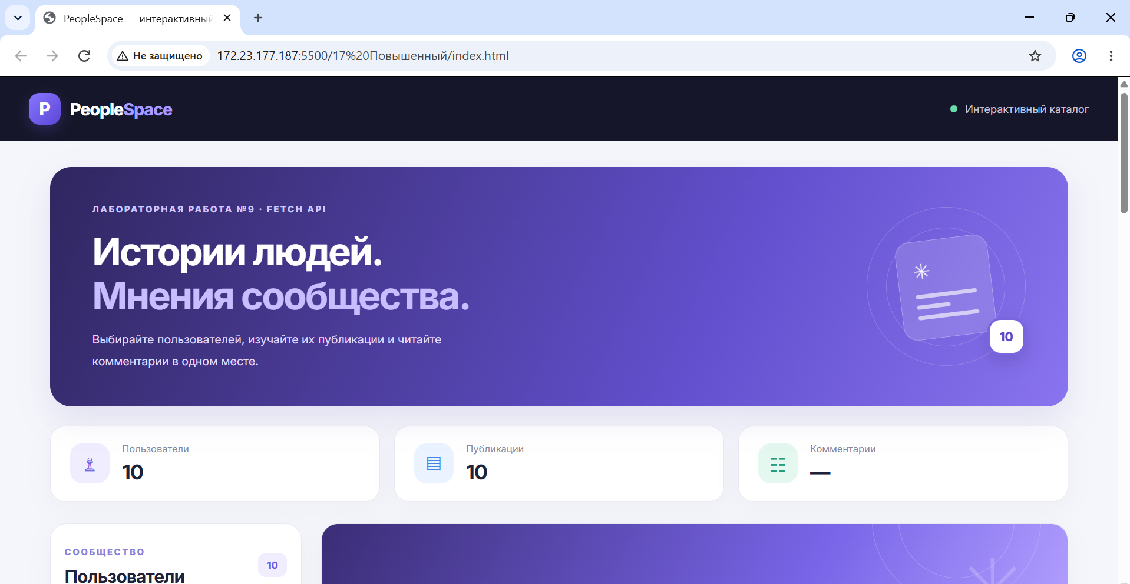

Коды:

App.js:

document.addEventListener('DOMContentLoaded', () => {
const usersList = document.querySelector('#usersList');
const userSearch = document.querySelector('#userSearch');
const globalStatus = document.querySelector('#globalStatus');

const userCount = document.querySelector('#userCount');
const postCount = document.querySelector('#postCount');
const commentCount = document.querySelector('#commentCount');
const sidebarCount = document.querySelector('#sidebarCount');

const welcome = document.querySelector('#welcome');
const profile = document.querySelector('#profile');

const profileAvatar = document.querySelector('#profileAvatar');
const profileName = document.querySelector('#profileName');
const profileUsername = document.querySelector('#profileUsername');
const profileEmail = document.querySelector('#profileEmail');
const profileCity = document.querySelector('#profileCity');
const profileCompany = document.querySelector('#profileCompany');

const profilePostCount = document.querySelector('#profilePostCount');
const postsStatus = document.querySelector('#postsStatus');
const postsList = document.querySelector('#postsList');

const commentsSection = document.querySelector('#commentsSection');
const selectedPost = document.querySelector('#selectedPost');
const selectedCommentCount =
document.querySelector('#selectedCommentCount');
const commentsStatus = document.querySelector('#commentsStatus');
const commentsList = document.querySelector('#commentsList');

let users = [];
let selectedUserId = null;
let selectedPostId = null;
let userRequestNumber = 0;
let postRequestNumber = 0;

const API = 'https://jsonplaceholder.typicode.com';

function initials(name) {
return name
.split(/\s+/)
.slice(0, 2)
.map(part => part[0] || '')
.join('')
.toUpperCase();
}

function setLoading(element, message) {
element.replaceChildren();

const spinner = document.createElement('span');
spinner.className = 'spinner';

element.append(spinner, document.createTextNode(message));
}

function showMessage(container, message, retry) {
container.replaceChildren();

const box = document.createElement('div');
box.className = 'empty-state';
box.textContent = message;

if (retry) {
const button = document.createElement('button');
button.className = 'retry-button';
button.textContent = 'Попробовать снова';
button.addEventListener('click', retry);
box.append(document.createElement('br'), button);
}

container.append(box);
}

async function request(url) {
const response = await fetch(url);

if (!response.ok) {
throw new Error(`Ошибка сервера: ${response.status}`);
}

return response.json();
}

function renderUsers() {
const query = userSearch.value.trim().toLowerCase();

const filteredUsers = users.filter(user =>
`${user.name} ${user.username} ${user.email}`
.toLowerCase()
.includes(query)
);

usersList.replaceChildren();
sidebarCount.textContent = filteredUsers.length;

if (filteredUsers.length === 0) {
showMessage(usersList, 'Пользователи не найдены.');
return;
}

filteredUsers.forEach((user, index) => {
const button = document.createElement('button');
button.className = 'user-item';

if (user.id === selectedUserId) {
button.classList.add('active');
}

button.style.animationDelay = `${index * 25}ms`;

const avatar = document.createElement('span');
avatar.className = 'user-avatar';
avatar.textContent = initials(user.name);

const info = document.createElement('span');
info.className = 'user-item-info';

const name = document.createElement('span');
name.className = 'user-item-name';
name.textContent = user.name;

const email = document.createElement('span');
email.className = 'user-item-email';
email.textContent = user.email;

const arrow = document.createElement('span');
arrow.className = 'user-arrow';
arrow.textContent = '›';

info.append(name, email);
button.append(avatar, info, arrow);

button.addEventListener('click', () => {
selectUser(user);
});

usersList.append(button);
});
}

async function selectUser(user) {
selectedUserId = user.id;
selectedPostId = null;

const currentRequest = ++userRequestNumber;
++postRequestNumber;

renderUsers();

welcome.hidden = true;
profile.hidden = false;

profileAvatar.textContent = initials(user.name);
profileName.textContent = user.name;
profileUsername.textContent = `@${user.username} · ID ${user.id}`;
profileEmail.textContent = user.email;
profileCity.textContent = user.address.city;
profileCompany.textContent = user.company.name;

profilePostCount.textContent = '…';
postsList.replaceChildren();
setLoading(postsStatus, 'Загружаем публикации пользователя...');
commentsSection.hidden = true;
commentsList.replaceChildren();
selectedPost.replaceChildren();
selectedCommentCount.textContent = '0';

postCount.textContent = '…';
commentCount.textContent = '—';

try {
const posts = await request(
`${API}/posts?userId=${user.id}`
);

if (currentRequest !== userRequestNumber) return;

profilePostCount.textContent = posts.length;
postCount.textContent = posts.length;
postsStatus.textContent = '';

if (posts.length === 0) {
showMessage(postsList, 'У пользователя пока нет публикаций.');
return;
}

renderPosts(posts);
} catch (error) {
if (currentRequest !== userRequestNumber) return;

console.error(error);

profilePostCount.textContent = '!';
postCount.textContent = '—';

showMessage(
postsList,
'Не удалось загрузить публикации. Проверьте интернет.',
() => selectUser(user)
);

postsStatus.textContent = '';
}
}

function renderPosts(posts) {
postsList.replaceChildren();

posts.forEach((post, index) => {
const button = document.createElement('button');
button.className = 'post-card';

const meta = document.createElement('div');
meta.className = 'post-meta';

const number = document.createElement('span');
number.className = 'post-number';
number.textContent =
`ПУБЛИКАЦИЯ ${(index + 1).toString().padStart(2, '0')}`;

const action = document.createElement('span');
action.className = 'post-action';
action.textContent = 'Читать комментарии →';

meta.append(number, action);

const title = document.createElement('h3');
title.textContent = post.title;

const body = document.createElement('p');
body.textContent = post.body;

button.append(meta, title, body);

button.addEventListener('click', () => {
loadComments(post, button);
});

postsList.append(button);
});
}

async function loadComments(post, selectedButton) {
if (selectedPostId === post.id) {
commentsSection.hidden = !commentsSection.hidden;
return;
}

selectedPostId = post.id;
const currentRequest = ++postRequestNumber;

document.querySelectorAll('.post-card').forEach(button => {
button.classList.remove('active');
});

selectedButton.classList.add('active');

commentsSection.hidden = false;
commentsSection.scrollIntoView({
behavior: 'smooth',
block: 'nearest'
});

selectedPost.replaceChildren();

const postTitle = document.createElement('strong');
postTitle.textContent = post.title;

const postText = document.createElement('div');
postText.textContent = post.body;
postText.style.marginTop = '7px';

selectedPost.append(postTitle, postText);

selectedCommentCount.textContent = '…';
commentCount.textContent = '…';

setLoading(commentsStatus, 'Загружаем комментарии к публикации...');
commentsList.replaceChildren();

try {
const comments = await request(
`${API}/posts/${post.id}/comments`
);

if (currentRequest !== postRequestNumber) return;

commentsStatus.textContent = '';
selectedCommentCount.textContent = comments.length;
commentCount.textContent = comments.length;

if (comments.length === 0) {
showMessage(
commentsList,
'К этой публикации пока нет комментариев.'
);
return;
}

comments.forEach(comment => {
const card = document.createElement('article');
card.className = 'comment-card';

const avatar = document.createElement('div');
avatar.className = 'comment-avatar';
avatar.textContent = initials(comment.name);

const content = document.createElement('div');
content.className = 'comment-content';

const name = document.createElement('h3');
name.className = 'comment-name';
name.textContent = comment.name;

const email = document.createElement('span');
email.className = 'comment-email';
email.textContent = comment.email;

const body = document.createElement('p');
body.className = 'comment-body';
body.textContent = comment.body;

content.append(name, email, body);
card.append(avatar, content);
commentsList.append(card);
});
} catch (error) {
if (currentRequest !== postRequestNumber) return;

console.error(error);
selectedCommentCount.textContent = '!';
commentCount.textContent = '—';

showMessage(
commentsList,
'Не удалось загрузить комментарии. Проверьте интернет.',
() => loadComments(post, selectedButton)
);

commentsStatus.textContent = '';
}
}

async function init() {
setLoading(globalStatus, 'Загружаем список пользователей...');

try {
users = await request(`${API}/users`);

userCount.textContent = users.length;
sidebarCount.textContent = users.length;
globalStatus.textContent = '';

renderUsers();

// Автоматически открываем первого пользователя.
if (users.length > 0) {
await selectUser(users[0]);
}
} catch (error) {
console.error(error);

userCount.textContent = '—';
globalStatus.textContent =
'Не удалось загрузить пользователей. Проверьте подключение.';

const retry = document.createElement('button');
retry.className = 'retry-button';
retry.textContent = 'Повторить загрузку';
retry.addEventListener('click', init);
globalStatus.append(' ', retry);
}
}

userSearch.addEventListener('input', renderUsers);

init();
});

Index.html:

<!DOCTYPE html>
<html lang="ru">
<head>
<meta charset="UTF-8">
<meta name="viewport" content="width=device-width, initial-scale=1.0">
<meta name="theme-color" content="#111827">
<title>PeopleSpace — интерактивный каталог</title>
<link rel="stylesheet" href="./style.css">
<script src="./app.js" defer></script>
</head>
<body>
<header class="topbar">
<a class="brand" href="#">
<span class="brand-icon">P</span>
<span>People<span class="brand-accent">Space</span></span>
</a>
<div class="topbar-label">
<span class="online-dot"></span>
Интерактивный каталог
</div>
</header>

<main class="page">
<section class="hero">
<div class="hero-copy">
<span class="eyebrow">ЛАБОРАТОРНАЯ РАБОТА №9 · FETCH API</span>
<h1>Истории людей.<br><span>Мнения сообщества.</span></h1>
<p>
Выбирайте пользователей, изучайте их публикации
и читайте комментарии в одном месте.
</p>
</div>
<div class="hero-art" aria-hidden="true">
<div class="art-circle circle-one"></div>
<div class="art-circle circle-two"></div>
<div class="art-card">
<span class="art-symbol">✳</span>
<span class="art-line"></span>
<span class="art-line short"></span>
<span class="art-line"></span>
</div>
<div class="art-bubble">10</div>
</div>
</section>

<section class="stats">
<div class="stat-card">
<span class="stat-icon purple">♙</span>
<div>
<span class="stat-label">Пользователи</span>
<strong id="userCount">—</strong>
</div>
</div>
<div class="stat-card">
<span class="stat-icon blue">▤</span>
<div>
<span class="stat-label">Публикации</span>
<strong id="postCount">—</strong>
</div>
</div>
<div class="stat-card">
<span class="stat-icon green">☷</span>
<div>
<span class="stat-label">Комментарии</span>
<strong id="commentCount">—</strong>
</div>
</div>
</section>

<div id="globalStatus" class="global-status" role="status">
<span class="spinner"></span>
Загружаем список пользователей...
</div>

<section class="workspace">
<aside class="sidebar">
<div class="section-title">
<div>
<span class="eyebrow">СООБЩЕСТВО</span>
<h2>Пользователи</h2>
</div>
<span class="count-pill" id="sidebarCount">0</span>
</div>

<label class="search-box">
<span>⌕</span>
<input id="userSearch" type="search"
placeholder="Найти пользователя..."
autocomplete="off">
</label>

<div id="usersList" class="users-list"></div>
</aside>

<section class="content">
<div id="welcome" class="welcome-panel">
<div class="welcome-icon">✦</div>
<h2>Всё начинается с человека</h2>
<p>
Выберите пользователя слева, чтобы загрузить
его публикации. Затем откройте публикацию,
чтобы прочитать комментарии.
</p>
<div class="steps">
<div><span>01</span> Пользователь</div>
<span class="step-arrow">→</span>
<div><span>02</span> Публикации</div>
<span class="step-arrow">→</span>
<div><span>03</span> Комментарии</div>
</div>
</div>

<div id="profile" class="profile-panel" hidden>
<div class="profile-cover">
<span class="cover-decoration">✳</span>
</div>
<div class="profile-main">
<div id="profileAvatar" class="profile-avatar">U</div>
<div class="profile-details">
<span class="eyebrow">ПРОФИЛЬ ПОЛЬЗОВАТЕЛЯ</span>
<h2 id="profileName">Имя пользователя</h2>
<p id="profileUsername" class="muted"></p>
</div>
</div>

<div class="profile-info">
<div class="info-box">
<span class="info-label">Электронная почта</span>
<span id="profileEmail" class="info-value"></span>
</div>
<div class="info-box">
<span class="info-label">Город</span>
<span id="profileCity" class="info-value"></span>
</div>
<div class="info-box">
<span class="info-label">Компания</span>
<span id="profileCompany" class="info-value"></span>
</div>
</div>

<div class="section-title posts-title">
<div>
<span class="eyebrow">ЛИЧНЫЙ БЛОГ</span>
<h2>Публикации</h2>
</div>
<span class="count-pill" id="profilePostCount">0</span>
</div>

<div id="postsStatus" class="inline-status" role="status"></div>
<div id="postsList" class="posts-list"></div>

<section id="commentsSection" class="comments-section" hidden>
<div class="section-title comments-heading">
<div>
<span class="eyebrow">ОБСУЖДЕНИЕ</span>
<h2>Комментарии</h2>
</div>
<span class="count-pill" id="selectedCommentCount">0</span>
</div>

<div id="selectedPost" class="selected-post"></div>
<div id="commentsStatus" class="inline-status" role="status"></div>
<div id="commentsList" class="comments-list"></div>
</section>
</div>
</section>
</section>

<footer>
<span class="brand-icon small">P</span>
<span>PeopleSpace</span>
<span class="footer-divider">·</span>
<span>Учебный проект на Fetch API</span>
</footer>
</main>
</body>
</html>

Контрольные вопросы:
1. Что такое AJAX и REST API?
AJAX технология обмена данными с сервером без перезагрузки страницы. REST APIинтерфейс взаимодействия программ через HTTP-запросы.
2. Чем асинхронный запрос отличается от синхронного?
Асинхронный не блокирует выполнение остального кода, а синхронный приостанавливает его выполнение до получения результата.
3. Что возвращает fetch()?
Возвращает Promise, который позволяет получить объект ответа сервера (Response).
4. Для чего нужны async и await?
async объявляет асинхронную функцию, а await ожидает результат выполнения Promise.
5. Почему следует проверять response.ok?
Чтобы убедиться, что сервер вернул успешный HTTP-статус, например 200.
6. Что делает response.json()?
Преобразует тело ответа в JavaScript-объект из формата JSON.
7. Как обработать ошибку сети?
Использовать try...catch для перехвата ошибок запроса.
8. Что такое CORS?
Механизм безопасности браузера, который регулирует запросы между разными источниками.
9. Чем отличаются GET и POST?
GET получает данные, а POST обычно отправляет данные на сервер.
10. Почему нельзя доверять содержимому ответа сервера?
Данные могут быть некорректными или вредоносными, поэтому их нужно проверять и безопасно выводить.
11. Как показать индикатор загрузки?
Отобразить сообщение «Загрузка…» перед запросом и скрыть его после завершения.
12. Для чего нужен AbortController?
Для отмены выполняющегося запроса, например если пользователь передумал ждать результат.

